Power BI Project: Sales & Revenue Analysis

Project overview
Project type
Sales & Revenue Analysis
Primary tool
Microsoft Power BI
Business context
Karcool Group
Dataset period
2014 U.S. sales data

1. Introduction
Sales and revenue analysis helps businesses understand how well their products perform, when customers purchase, which product categories generate the most revenue, and which customers contribute significantly to sales.
My first Power BI project, Sales & Revenue Analysis for Karcool Group, involved transforming U.S. sales data from 2014 into a business intelligence report designed to communicate sales performance through interactive visualizations and meaningful insights.
The purpose was to move beyond raw transactional records and present information in a format that supports business decisions. By examining revenue across time periods, product categories, customers, regions, and payment methods, the project aimed to identify performance patterns, highlight areas of strength, and reveal opportunities for improvement.
This project also represents an important step in my development as a data analyst. It allowed me to apply Power BI to a practical business problem and develop a structured approach to communicating analytical findings to stakeholders.

2. Analytical approach and data story
The analytical approach followed a business-focused process: understand the data, examine the major performance indicators, investigate patterns across relevant dimensions, and translate the results into actionable recommendations.
The central business question was:
How can Karcool Group use its sales data to understand revenue performance, identify its strongest sales drivers, and improve commercial decision-making?
The analysis explored five areas:
- Time-based performance: How did sales change across months and quarters?
- Product performance: Which categories and products generated the most revenue or sales volume?
- Customer contribution: Which customers accounted for significant portions of sales?
- Geographic performance: Which U.S. regions contributed the most to revenue?
- Payment behaviour: Which payment methods accounted for the largest share of transactions or sales?
Together, these areas provide a clearer picture of where revenue originates and where management may need to investigate further.

3. Instruments used
Instrument | Purpose
Microsoft Power BI Desktop | Data modelling, report development, and visualization
Power Query | Data inspection and preparation, where applied
DAX | Calculated measures and analytical calculations, where applied
Power BI visuals | Comparing sales across categories, customers, periods, and regions
Interactive report pages | Organizing the analytical story and presenting results
These tools describe the Power BI workflow. Only list individual Power Query transformations or DAX measures as completed skills if you actually performed them in this project.

4. Pre-analysis
Before interpreting the results, the first stage was to establish the business context and identify the dimensions needed to answer the analytical questions.
The preparation stage focused on understanding the available sales fields, identifying the measures that could be compared, and organizing the report around the questions management would want answered.
The main analytical dimensions included:
- Date and time period
- Product and product category
- Customer and company
- U.S. geographic region
- Payment method
- Sales or revenue value
- Product quantity, where relevant
The pre-analysis stage is important because dashboard quality depends on more than visual design. Accurate conclusions require suitable data types, consistent categories, valid dates, and measures that reflect the intended business definitions.
Analytical objective: Establish a reliable foundation for evaluating sales performance and communicating the results clearly.

5. Observations and key findings
The analysis produced several notable findings across revenue, product categories, customers, geography, and time.
Overall performance

$435K+
Reported total revenue
The report indicated total revenue exceeding $435,000, providing an overall reference point for evaluating the business's sales performance.
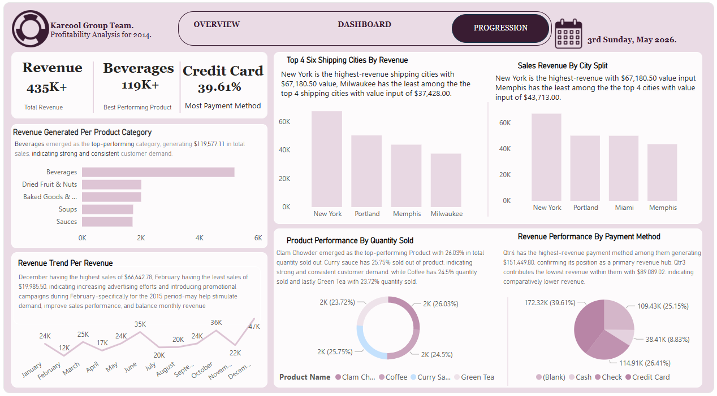
Monthly performance

$66,642.78
December: highest month
February recorded the lowest monthly revenue at $19,985.50. This difference points to substantial variation in monthly performance and a need to investigate seasonality, demand, and sales activity.
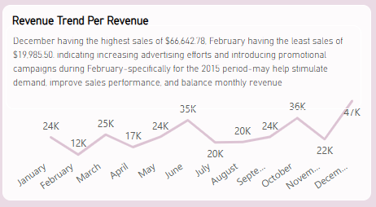

Product category

$119,577.11
Beverages: highest-revenue category
Beverages led the reported category results. This makes the category a useful starting point for investigating product demand, stock availability, and opportunities for complementary sales.

Customer performance

$104,252.34
Nancy Freehafer: leading reported sales contributor
This result highlights the importance of understanding high-value customers and assessing whether sales are concentrated among a small number of buyers.

Geographic performance

≈ $91.25K
West: leading reported region
The West region generated approximately $91,250 in revenue, indicating a strong contribution to overall sales. Further analysis could reveal which products and customers drove this performance.

Additional observations included:
- Quarterly performance: Q4 generated $151,449.80, the strongest reported quarter, while Q3 generated approximately $89,089.02.
- Payment methods: Credit cards accounted for 39.61% of the reported payment-method measure.
- Product-level results: Coffee generated $75,486.96 from 1,641 units. Clam Chowder recorded 1,744 units and $16,829.60 in sales.
- Customer rankings: Company D was reported at $67,180.50, while Company K recorded $21,937.08 among the top-10 customer results.
These figures show that sales performance varied across periods, categories, products, regions, and customers. They should be interpreted within the scope of the dataset rather than as evidence of profitability or future performance.

6. In-analysis: turning observations into business insights
The in-analysis stage focused on interpreting the reported results and considering what they might mean for business operations.

A. Revenue concentration across months and quarters
December's reported revenue was more than three times February's. Q4 also outperformed the other reported quarters.
Key insight derived: Sales activity was not evenly distributed throughout the year.
Business interpretation: The company may experience seasonal demand, differences in customer purchasing cycles, or changes in sales activity. The dashboard identifies the pattern, but additional historical data would be needed to establish whether it represents a recurring seasonal trend.
Actionable recommendation: Review the products, customer segments, and sales activities responsible for the stronger periods. Use the findings to plan inventory, staffing, and marketing campaigns ahead of expected demand.

B. Category and product performance
Beverages was the leading reported revenue category, while Coffee was a notable product contributor.
Key insight derived: Some categories and products contribute more revenue than others.
Business interpretation: Category-level results can help management prioritize its product assortment. However, high revenue does not necessarily mean high profitability because product costs and operating expenses have not been established by these figures.
Actionable recommendation: Investigate product-level sales, availability, unit costs, and margins before making pricing or inventory decisions. Consider complementary-product promotions where purchasing behaviour supports them.

C. Customer contribution
Nancy Freehafer was the leading reported customer by sales, and the company-level rankings showed differences among major contributors.
Key insight derived: Customer contributions are not necessarily equal.
Business interpretation: High-value customers may offer opportunities for retention and relationship development. At the same time, excessive dependence on a small number of customers could expose the business to revenue volatility.
Actionable recommendation: Examine the percentage of total revenue generated by the top five or ten customers. Develop suitable retention initiatives while identifying opportunities to acquire and grow other customer accounts.

D. Geographic performance
The West region generated approximately $91.25K in reported revenue.
Key insight derived: Revenue contributions vary by geographic region.
Business interpretation: Regional differences may reflect customer concentration, product preferences, market size, or sales coverage.
Actionable recommendation: Compare regional product mixes and customer segments. Investigate lower-performing regions before allocating additional marketing budgets or sales resources.

E. Payment-method behaviour
Credit cards represented 39.61% of the reported payment-method measure.
Key insight derived: Credit cards were an important part of the observed payment mix.
Business interpretation: Payment preferences can influence the customer experience and the way the business monitors transaction activity.
Actionable recommendation: Maintain reliable support for commonly used payment methods and assess transaction costs, payment success rates, and customer preferences before changing payment policies.

7. My Power BI dashboard
The uploaded report is organized into six pages, including two main dashboard pages. Each page contributes to the presentation of the analytical process.
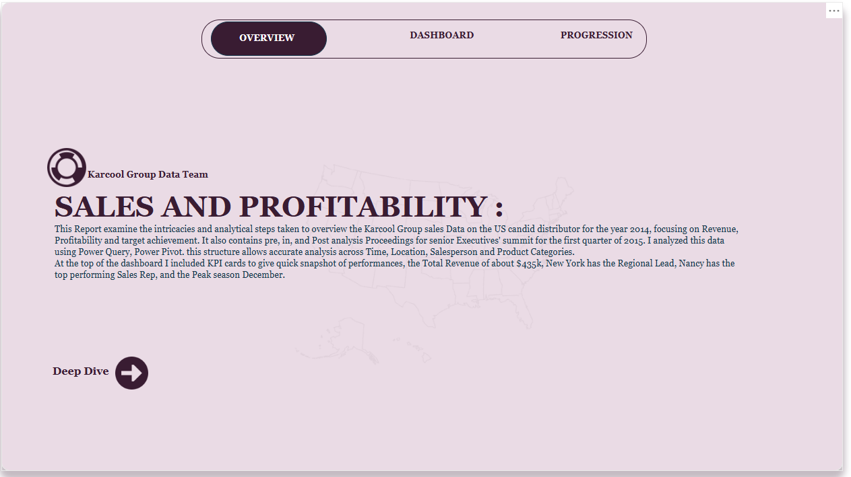
Page 1: Introduction
Establishes the project context and introduces the report to its audience.
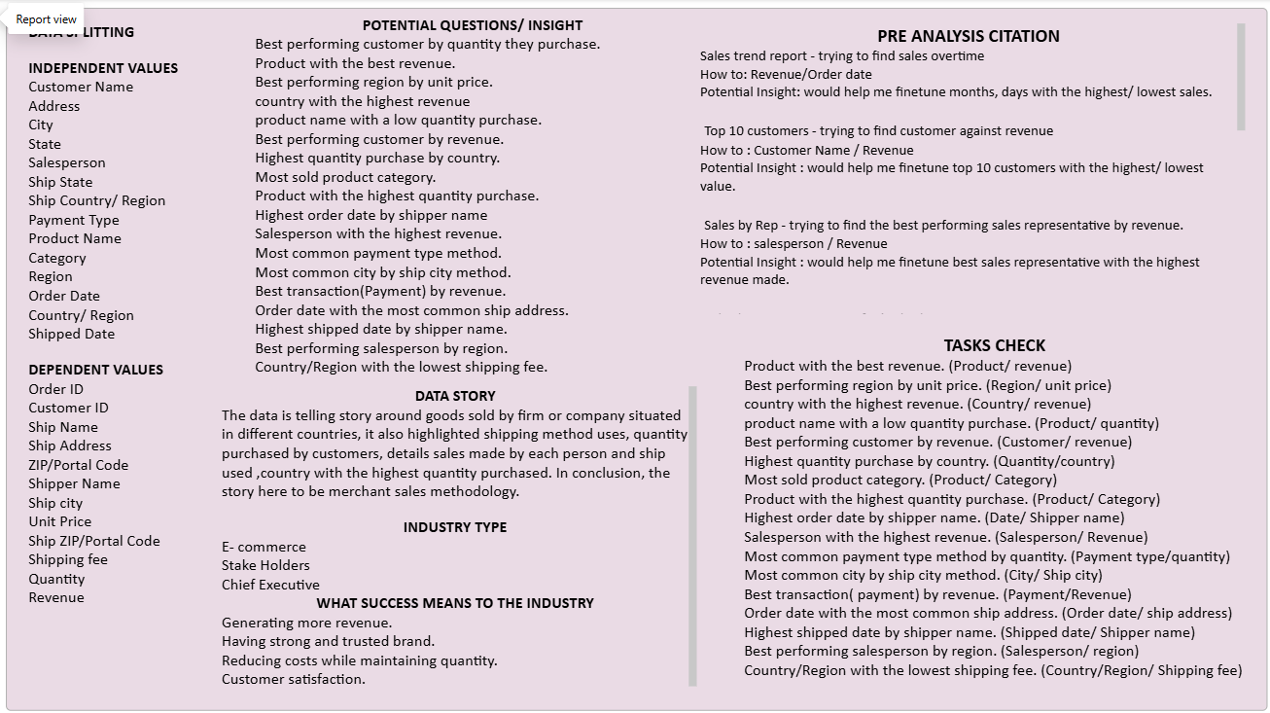
Page 2: Pre Analysis
Supports an initial understanding of the dataset and the analytical context.
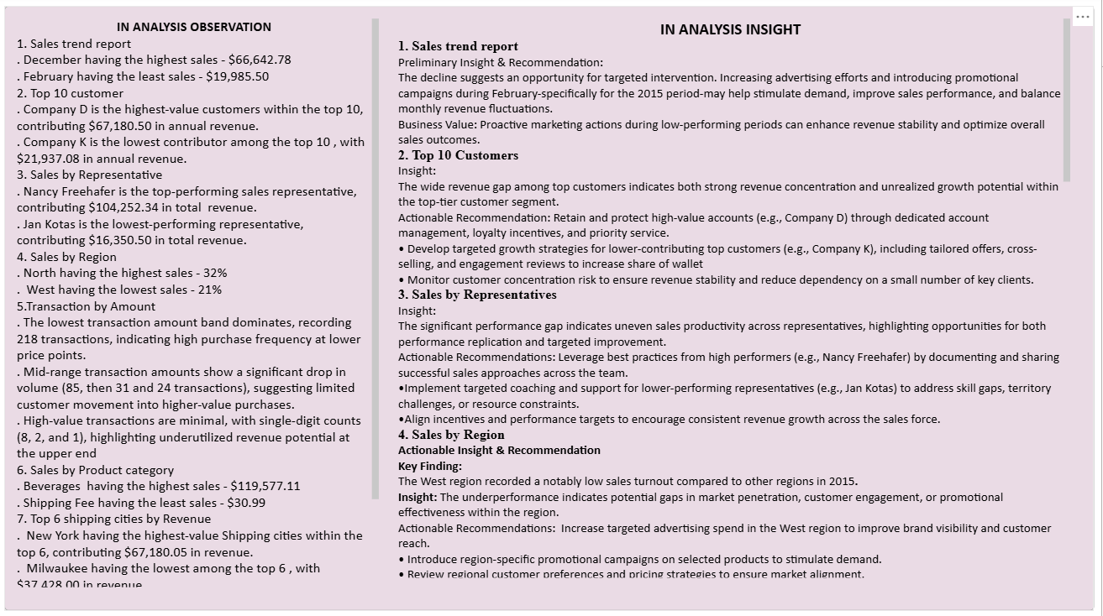
Page 3: In Analysis
Presents the analytical stage where patterns and performance differences can be investigated.
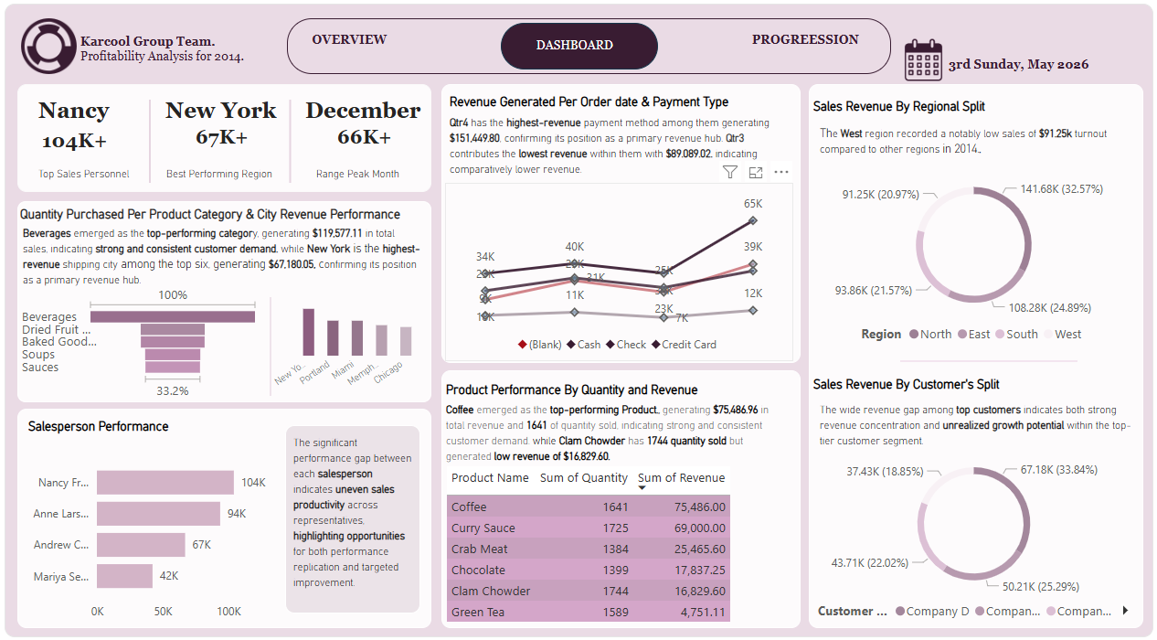
Page 4: Dashboard 1
Provides a dashboard view for exploring and comparing sales performance.
Page 5: Dashboard 2
Offers an additional dashboard view to support deeper examination of the report's sales dimensions.

The report's value lies in connecting the numerical results with a clear narrative. The introduction establishes context, the analytical pages provide structure, and the two dashboard pages are the main artifacts through which users can explore the findings.

8. Who this analysis matters to, and why
Audience | Why the analysis matters
Sales managers | Identify strong and weak sales periods and monitor category performance.
Business owners and executives | Understand where revenue originates and where further investigation may be needed.
Marketing teams | Identify periods, categories, regions, and customers that may warrant targeted campaigns.
Inventory and operations teams | Use observed product demand patterns to support stock and resource planning.
Customer relationship teams | Identify high-value accounts and assess customer concentration.
Finance teams | Use sales findings as an input to more complete financial analysis, including cost and margin assessment.
This analysis is most useful when decision-makers combine the dashboard findings with business context, cost information, and operational data. Revenue alone does not establish whether the company is financially healthy.

9. Post-analysis insights
The analysis established several areas worth prioritizing:
- Investigate sales seasonality. December and Q4 were the strongest reported periods, while February and Q3 were comparatively weaker.
- Understand category contribution. Beverages was the leading category by reported revenue, making it a priority for further product and margin analysis.
- Monitor customer concentration. Leading customer contributions should be examined alongside the overall customer base.
- Compare regional performance. The West region's reported contribution provides a reference point for investigating differences across markets.
- Connect revenue with profitability. Revenue performance should be supplemented with cost, gross profit, and margin measures before drawing financial conclusions.
The distinction between an observation and a conclusion is important. For example, December's high revenue is an observed result. Concluding that a holiday campaign caused it would require additional evidence.

10. Overall recommendations
Based on the reported findings, I recommend the following priorities for Karcool Group.
1. Develop a monthly sales monitoring process
Compare actual sales with targets, investigate large monthly variations, and use prior-period results to support planning.
2. Strengthen product and inventory decisions
Review sales volume, availability, cost, and margin at product level. Avoid assuming that the highest-revenue product is necessarily the most profitable.
3. Improve customer retention and diversification
Assess top-customer revenue concentration, maintain relationships with valuable accounts, and identify opportunities to expand the wider customer base.
4. Investigate regional sales differences
Examine regional product demand and customer composition before deciding where to increase marketing or sales investment.
5. Extend the report to profitability analysis
Where reliable cost data is available, add gross profit, gross margin, and product profitability measures. This would allow management to distinguish high-revenue activities from genuinely profitable ones.

11. Conclusion
My first Power BI Sales & Revenue Analysis project demonstrates how business data can be transformed into a structured analytical story. By examining sales across time, products, customers, regions, and payment methods, I identified patterns that can inform further investigation and business planning.
The project strengthened my ability to organize a business intelligence report, communicate findings through visualizations, and connect numerical observations with practical recommendations.
It also reinforced an important analytical principle: a dashboard should do more than display numbers. It should help its audience understand what happened, investigate why it may have happened, and decide what to examine or do next.
This project represents a foundation for my continued development in data analytics and business intelligence using Microsoft Power BI.

